1. **Develop and demonstrate a HTML5 file that includes JavaScript script that uses functions for the following problems :**

**a. Parameter: A string Output: The position in the string of the left-most vowel.**

**b. Parameter: A number Output: The number with its digits in the reverse order**

**CODE :**

<!DOCTYPE html>

<html lang="en">

<head>

<meta charset="UTF-8">

<meta http-equiv="X-UA-Compatible" content="IE=edge">

<meta name="viewport" content="width=device-width, initial-scale=1.0">

<title>Math Calculations</title>

<style>

body {

font-family: 'Times New Roman', Times, serif;

font-size: 20px;

background-color: paleturquoise;

}

h1,h3 {

text-align: center;

}

input {

height: 70px;

width: 150px;

position: relative;

top: 50%;

left: 50%;

}

</style>

<script type="text/javascript">

function str_vowel(){

var str = prompt("Enter any string\n"," ");

for(var i=1; i<=str.length; i++){

if(str.charAt(i)=='a'||str.charAt(i)=='e'||str.charAt(i)=='i'||str.charAt(i)=='o'||str.charAt(i)=='u'||str.charAt(i)=='A'||str.charAt(i)=='E'||str.charAt(i)=='I'||str.charAt(i)=='O'||str.charAt(i)=='U'){

document.write("The entered string is : "+str+"<br>");

document.write("The leftmost vowel is : "+str.charAt(i)+"<br>");

var pos=i+1;

document.write("The position of the leftmst vowel "+str.charAt(i)+ " is : "+pos+"\n");

exit;

}

}

document.write("The entered string is : "+str+"<br>");

document.write("The entered string has no vowels");

}

function number() {

var a = prompt("Enter a number : ");

var b = a;

var n = 0;

var n1 = 0;

while(a!=0){

n = a%10;

n1 = (n1*10)+n;

a = Math.floor(a/10);

}

document.write("The reverse the number is "+n1+"<br>");

}

function factorial() {

var f = prompt("Enter a number : ");

var fact = 1;

for(var j=1; j<=f; j++)

{

fact = fact * j;

}

document.write("The factorial of "+f+" number is "+fact);

}

function table(){

var num = prompt("Enter a number : ");

for(var k=1; k<=10; k++)

{

document.write(num+" * "+ k +" = "+num*k+"<br>");

}

}

</script>

</head>

<body>

<h1>WELCOME TO THE MATH CALCULATIONS</h1>

<h3>Click on the string button for the position of the leftmost vowel application, on the number button for the reverse number application, on the factorial button for the factorial of number and table for the table of a number. Both the buttons are below.</h3>

<input type="button" value="String" onclick="str_vowel()"><br><br>

<input type="button" value="Number" onclick="number()"><br><br>

<input type="button" value="Factorial" onclick="factorial()"><br><br>

<input type="button" value="Table" onclick="table()">

</body>

</html>

**OUTPUT :**

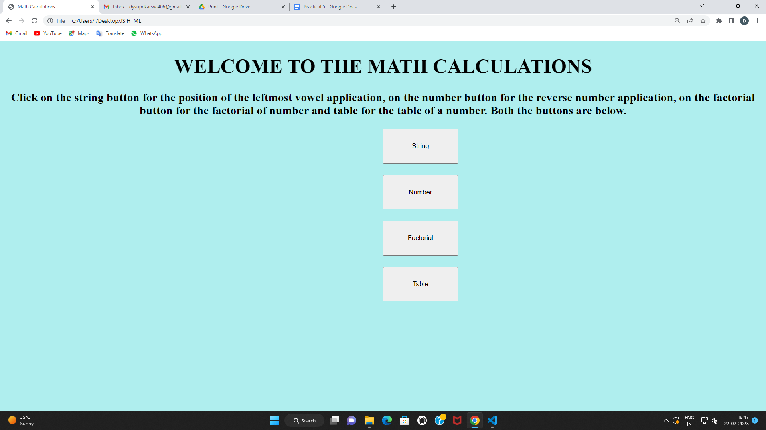

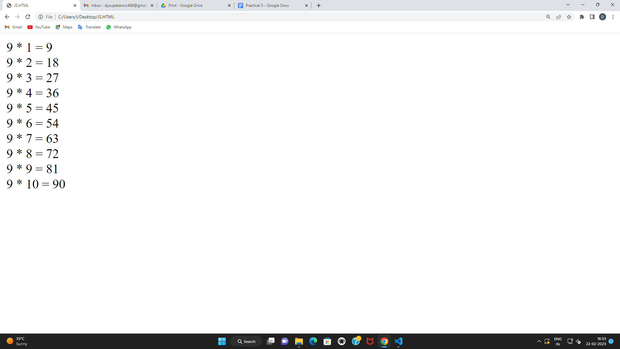

1. **Write a JavaScript code that displays text “TEXT- GROWING” with increasing font size in the interval of 100ms in RED COLOR, when the font size reaches 50pt it displays “TEXT-SHRINKING” in BLUE color. Then the font size decreases to 5pt.**

**CODE :**

<html>

<head>

<style>

p{

position:absolute;

top:50%;

left:50%;

transform: translate(-50%,-50%);

background-color: blanchedalmond;

}

body{

background-color: turquoise;

}

</style>

</head>

<body>

<p id="demo"></p>

<script>

var var1=setInterval(inTimer,1000);

var size=5;

var ids=document.getElementById("demo");

function inTimer(){

size+=5;

ids.innerHTML="TEXT GROWING";

ids.setAttribute("style","font-size:"+size+"px; color:black");

if(size>=50)

{

clearInterval(var1);

var var2=setInterval(deTimer,1000);

}

}

function deTimer(){

size-=5;

ids.innerHTML="TEXT SHRINKING";

ids.setAttribute("style","font-size:"+size+"px; color:blue");

if(size<=5)

{

clearInterval(var1);

}

}

</script>

</body>

</html>

**OUTPUT :**

